DAA Report Week 12

N Queens Problem (4X4 Grid)

Shashank K

SE21UCSE198

CSE 3

**Program**

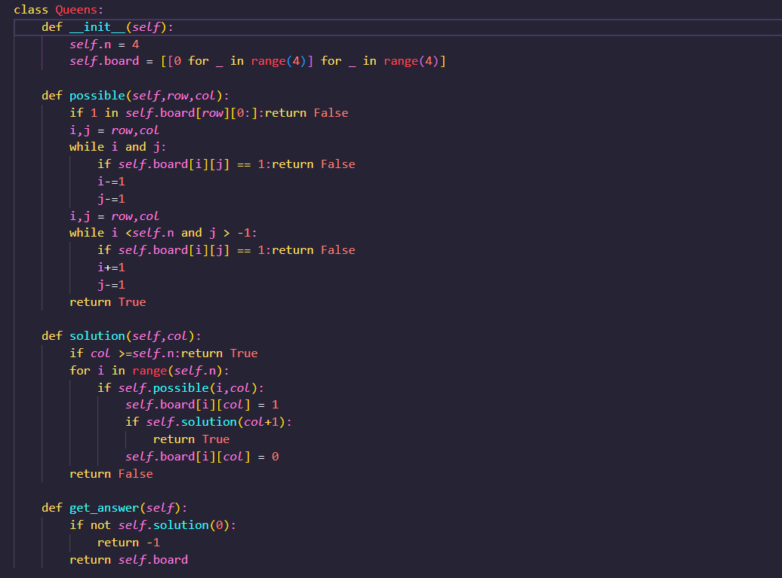

**Methods:**

possible : Checks whether a queen can be placed on grid at point (row,col). Checking makes sure that there are no attacking queens present.

Solution : An iterative method that implements the n-queens algorithm. We try placing in each row one by one in the respective column.

Get_answer : Driver method that checks if it solution is possible and returns respective board configuration.

Output:

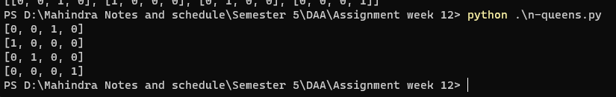

Time complexity : O(N!) Space Complexity : O(N2)

where N is the board size

**THE END**